**INTRODUCTION**

This project is a shopping list for users. The project objective is to deliver the shopping list application into Android platform. This project is an attempt to provide the advantages of shopping list to customers of a real shop. It helps buying the products in the shop anywhere through by using an android device. When people make a list of some important stuff to buy, they often forget some. Going to a market or shop and coming back without the essentials you wished to buy is the most annoying experience. Apart from making you an organized shopper, a shopping list also provides other varieties of benefits to any user. However, coming up with an effective shopping list may prove to be a hard task. It is even worse when you don’t know what to include on the list and what not to. This is the stage you might want to have a shopping list template to guide you through making a shopping list. Therefore, in today’s life where there is plenty of automation and technology, people are not really concentrating on small matters such as coming up with a shopping list from scratch. That is why they prefer an already made template to guide them Shopping List brings the opportunity to purchase your crafts smartly.

**USERS**

In general, shopping has always catered to middle class and upper class women. Shopping is fragmented and pyramid-shaped. At the pinnacle are elegant boutiques for the affluent; a huge belt of inelegant but ruthlessly efficient “discounters” flog plenty at the pyramid’s precarious middle. According to the analysis of Susan D. Davis, at its base are the world’s workers and poor, on whose cheapened labor the rest of the pyramid depends for its incredible abundance.

Shopping has evolved from single stores to large malls containing many stores that most often offer attentive service, store credit, delivery, and acceptance of returns. These new additions to shopping have encouraged and targeted middle class women.

In recent years, online shopping has become popular; however, it still caters to the middle and upper class. In order to shop online, one must be able to have access to a computer, a bank account and a debit card. Shopping has evolved with the growth of technology. According to research found in the Journal of Electronic Commerce, if we[who?] focus on the demographic characteristics of the in-home shopper, in general, the higher the level of education, income, and occupation of the head of the household, the more favourable the perception of non-store shopping. An influential factor in consumer attitude towards non-store shopping is exposure to technology, since it has been demonstrated that increased exposure to technology increases the probability of developing favourable attitudes towards new shopping channels.

1.1 PROJECT OBJECTIVE:

The objective of the project is to make an application in android platform to purchase items . In order to build such an application complete web support need to be provided. A complete and efficient web application which can provide the shopping list experience is the basic objective of the project. The web application can be implemented in the form of an android application with web view.

1.2 PROJECT OVER VIEW:

The central concept of the application is to allow the customer to shop using the app and allow customers to buy the items and articles of their desire from the store. The information pertaining to the products are stores on an DBMS at the server side (store). The application for the customers who wish to buy the articles.

1.3 How Does This Application Work?

Create custom shopping lists and track your last purchase date and quantity for every item you buy with Shopping List!

Shopping List is easy to use, robust and offers the ability to track your shopping list without any fuss.

Whether you want to save time, cut down on the amount of money you spend, or just get the best organization possible on your shopping trips, Shopping List is the app for you!

1.4 Features of Ultimate Shopping List App:

TRACK MULTIPLE LISTS – Never worry that you've only got one list or have to juggle multiple paper lists again!

TRACK PURCHASE DATES – Don't remember when you bought that item? Not sure just how often you have to resupply? Ultimate Shopping List tracks all your purchase dates!

TRACK THE NUMBER OF ITEMS BOUGHT – Looking to slash wasted spending and ramp up your savings? Ultimate Shopping List does that!

AUTOMATIC LIST SAVING – Tired of forgetting your lists, or forgetting to save them? Never worry about it again with the automatic saving feature!

SAVE TIME – Creating lists with Ultimate Shopping List is simple, easy and effective, saving you tons of time and headaches now and while shopping.

SETUP AS MANY LISTS AS YOU LIKE – Shopping Lists supports as many different lists as you'd like to make, giving you the ability to create lists for:

One off items

Regular items

Semi-frequent purchases

Anything else you can think of!

**MANAGE PRODUCTS**

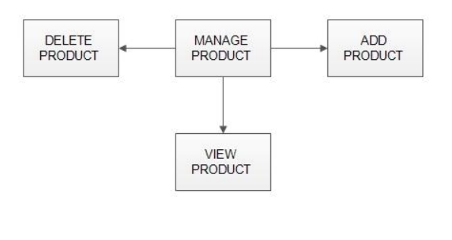

➢ Add Products

The shopping list project contains different kind of products. The products can be classified into different categories by name. Admin can add new products into the existing system with all its details including an image.

➢ Delete Products

Administrator can delete the products based on the stock of that particular product.

➢ Search products

Admin will have a list view of all the existing products. He can also search for a particular product by name.

**MANAGE USER**

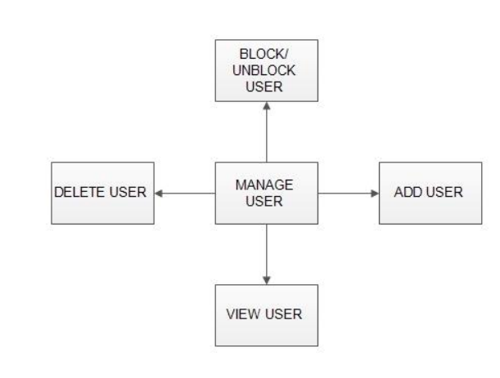

- View Users The admin will have a list view of all the users registered in the system. Admin can view all the details of each user in the list except password.

- Add Users Admin has privileges to add a user directly by providing the details.

- Delete &Block Users Administrator has a right to delete or block a user. The default status of a new user registered is set as blocked. The admin must accept the new user by unblocking him.

**- Registration**

A new user will have to register in the system by providing essential

details in order to view the products in the system. The admin must accept a new user by unblocking him.

➢ **Login**

A user must login with his user name and password to the system after registration.

➢ **View Products**

User can view the list of products based on their names after successful login. A detailed description of a particular product with product name, products details, product image, price can be viewed by users.

➢ **Add to list:**

The user can add the desired product into list by clicking add to list option on the product.

He can view his list by clicking on the list button. All products added by list can be viewed in the list. User can remove an item from the list by clicking remove.

**SYSTEM ANALYSIS**

System analysis is the process of gathering and interpreting facts, diagnosing problems and using the information to recommend improvements on the system. System analysis is a problem solving activity that requires intensive communication between the system users and system developers. System analysis or study is an important phase of any system development process. The system is viewed as a whole, the inputs are identified and the system is subjected to close study to identify the problem areas. The solutions are given as a proposal. The proposal is reviewed on user request and suitable changes are made. This loop ends as soon as the user is satisfied with the proposal.

Create custom shopping lists and track your last purchase date and quantity for every item you buy with Shopping List!

Shopping List is easy to use, robust and offers the ability to track your shopping list without any fuss.

Whether you want to save time, cut down on the amount of money you spend, or just get the best organization possible on your shopping trips, Shopping List is the app for you!

EFFICIENCY REQUIREMENT

When an online shopping list android application implemented customer can purchase product in an efficient manner.

RELIABILITY REQUIREMENT

The system should provide a reliable environment to both customers and owner. All orders should be reaching at the admin without any errors.

USABILITY REQUIREMENT

The android application is designed for user friendly environment and

ease of use.

Description of feature

This feature used by the user to login into system. A user must login with his user name and password to the system after registration. If they are invalid, the user not allowed to enter the system.

Functional requirement –

Username and password will be provided after user registration is confirmed. - Password should be hidden from others while typing it in the field

- REGISTER NEW USER

A new user will have to register in the system by providing essential

details in order to view the products in the system. The admin must accept

a new user by unblocking him.

Functional requirement

- System must be able to verify and validate information.

- The system must encrypt the password of the customer to provide security.

**SYSTEM DESIGN**

System design is the solution for the creation of a new system. This phase focuses on the detailed implementation of the feasible system. It emphasis on translating design. Specifications to performance specification. System design has two phases of development

➢ Logical design

➢ Physical design

During logical design phase the analyst describes inputs (sources), output s(destinations), databases (data sores) and procedures (data flows) all in a format that meets the user requirements. The analyst also specifies the needs of the user at a level that virtually determines the information flow in and out of the system and the data resources. Here the logical design is done through data flow diagrams and database design. The physical design is followed by physical design or coding. Physical design produces the working system by defining the design specifications, which specifyexactly what the candidate system must do. The programmers write the necessary programs that accept input from the user, perform necessary processing on accepted data and produce the required report on a hard copy or display it on the screen.

|  |  |
| --- | --- |
| **System Feature _ID** | SF_SC_CUST_02 |
| **Requirement_ID** | SC_CUST_LI_01 |
| **Actor** | Customer |
| **Business logic** | * 1. Clicks on login button   2. Display login page   3. Enter userid and password   4. perform client side validation   5. Send data for server to perform business operation   6. Establishes database connection   7. Returns connection message acknowledgement   8. Check for validity of login credentials   9. Display the home page |
| **Client side validations** | 1. Check for the entry of userid 2. Check for the entry of password |
| **Server side validations** | Check for validity of userid and password |

User Stories

As a user, I want to register an account in order to be able to save my purchases.

As a user, I want to log in as a guest to try this app. As a user, I want to be able to delete my entry.

As a user, I want to purchase a membership so that my account is fully functional.

As a user, I want to change my personal information if I need to.

As a user, I want to be able to create list.

As a user, I want to set a different list priority type.

As a user, I want to be able to view a list of purchases that need to be made.

As a user, I want to be able to view the shopping list.

As a user, I want to be able to view the list of completed purchases.

As a user, I want to be able to drag a task to the next state.

As a user, I want to be able to view the purchases I made.

As a user, I want to be able to view daily purchases.

As a user, I want to be able to view weekly purchases.

As a user, I want to be able to delete purchases.

As a user, I want to be able to search for purchases.

DATABASE DATABASE DESIGN:

Databases are the storehouses of data used in the software systems. The data is stored in tables inside the database. Several tables are created for the manipulation of the data for the system. Two essential settings for a database are - the field that is unique for all the record occurrences. -the field used to set relation between tables. Normalization is a technique to avoid redundancy in the tables.

**TABLE STRUCTURE**

**USERS TABLE**

|  |  |  |  |  |  |
| --- | --- | --- | --- | --- | --- |
| **Column name** | **Data type** | **size** | **Allow nulls** | **Constraints** | **Remarks** |
| Username | varchar | 50 | true |  |  |
| Uid | varchar | 50 | true | Foreign key |  |
| Email | varchar | 50 | true |  |  |
| Password | varchar | 50 | true |  |  |
|  |  |  |  |  |  |

**List TABLE**

|  |  |  |  |  |  |
| --- | --- | --- | --- | --- | --- |
| **Column name** | **Data type** | **size** | **Allow nulls** | **Constraints** | **Remarks** |
| L_ID | varchar | 50 | False | Primary key |  |
| L_Name | varchar | 50 | True |  |  |
| price | decimal | (18,0) | True |  |  |
|  |  |  |  |  |  |

**LOGIN**

|  |  |  |  |  |  |
| --- | --- | --- | --- | --- | --- |
| **Column name** | **Data type** | **size** | **Allow nulls** | **Constraints** | **Remarks** |
| U_ID | varchar | 50 | False | Primary key |  |
| Username | varchar | 50 | True |  |  |
| Password | Varchar | 50 | True |  |  |
|  |  |  |  |  |  |

**3.5 E-R DIAGRAMS**

**LOGIN**

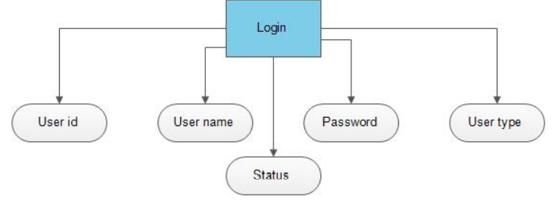

**USER DETAILS**

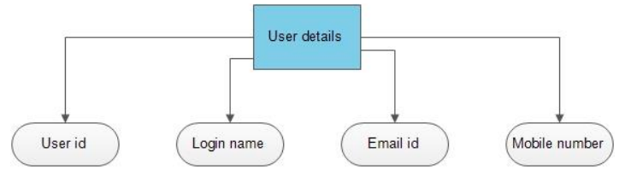

**PRODUCT DETAILS**

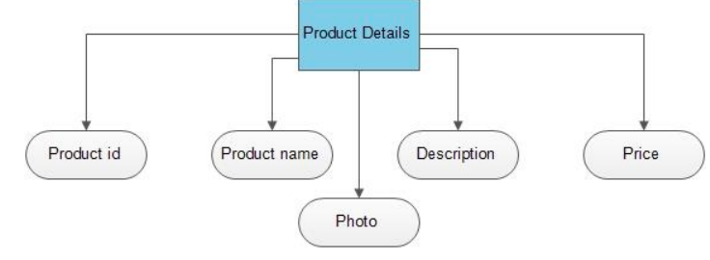

**COMPLETE DIAGRAM**

